**Summary Table for Multivariable Logistic Regression**

**Macro:** MULTIPLE_LOGREG

**Created Date/Author:** June 26, 2012/Dana Nickleach

**Last Update Date/Person**: Jan, 2017/Yaqi Jia

**Other Significant Contributor**: Yuan Liu

**Current Version**: V16

**Working Environment:** SAS 9.4 English version

**Contact**: Dr. Yuan Liu [yliu31@emory.edu](mailto:yliu31@emory.edu)

**Purpose:** To produce a summary table in a Microsoft Word Document from a multivariable logistic regression model. The modeling must be done before using this macro.

**Notes:** The logistic regression must be conducted using PROC LOGISTIC before calling this macro. A binary logit, cumulative logit, or generalized logit model can be used. Six tables must be created using ODS output when running PROC LOGISTIC (ODS OUTPUT NObs = nobs Type3 = type3 ParameterEstimates = estimate CLparmWald = CI ModelInfo=modelinf ResponseProfile=resp).

The options PARAM=GLM and CLPARM=WALD must also be used in the PROC. Variable names must not

be more than 20 characters. This macro can be set up to handle models including interaction terms when the outcome is binary, and in the model fitting step, use SLICE statement to specifiy how the strafied analysis to be conducted and also use ODS OUTPUT SliceDiffs = slices_diff.

**Parameters:**

|  |  |
| --- | --- |
| **Macro variable** | **Description** |
| EVENT | The event category for the binary response model (optional). Specify the value without quotes. This will appear in the table header. If using a clogit or glogit model, leave this blank. |
| OUTPATH | File path for output table to be stored. |
| FNAME | File name for output table. |
| FOOTNOTE | Text of footnote to include in the table (optional). It should be in quotes. This footnote will appear below the footnote containing the number of observations. Leave this field blank if not including an additional footnote. |
| TYPE3 | Set to F to suppress type III p-values from being reported in the table (optional). The default value is T. |
| EFFECT | If not empty, then the model contains a two-way interaction. It is used to specify the treatment effect in the interaction. |
| SLICEBY | Use in combine with EFFECT to specify the stratified variable in the interaction. |
| SHORTREPORT | Use in combine with EFFECT and SLICEBY when there is an interaction in the model and set to T to only report the stratified treatment effect. |
| DEBUG | Set to T if running in debug mode (optional). Work datasets will not be deleted in debug mode. This is useful if you are editing the code or want to further manipulate the resulting data sets. The default value is F. |

**Usage Example:**

**DATA** analysis;

input id os_censor Sex $ Age duration os progress $ trt $;

LABEL os = 'Overall Survival (months)'

progress = 'Progression'

trt = 'Treatment'

duration = 'Duration of Radiation';

DATALINES;

1 1 M 40 44 20 No B

2 1 F 45 46 16 Yes A

3 1 F 40 32 20 No B

4 1 F 47 32 23 No B

5 0 M 41 25 22 No B

6 1 M 54 35 13 No B

7 1 M 48 50 9 Yes A

8 1 M 36 33 12 Yes B

9 0 F 49 51 8 Yes A

10 1 M 49 52 10 Yes A

11 1 M 44 35 12 No A

12 1 M 49 50 8 Yes A

13 1 M 44 44 14 Yes A

14 1 M 50 31 10 Yes A

15 1 M 53 40 15 No B

16 0 M 52 29 20 Yes B

17 1 F 46 45 5 Yes A

18 1 F 37 44 11 Yes A

19 1 M 49 46 13 No B

20 1 M 42 31 11 No A

;

TITLE 'Table 4 Logistic Regression';

ODS OUTPUT NObs = nobs Type3 = type3 ParameterEstimates = estimate CLparmWald = CI ModelInfo=modelinf ResponseProfile=resp;

PROC LOGISTIC data = analysis;

class Trt Sex/param=glm;

model progress(event='Yes') = Trt Sex Age Duration/CLPARM=wald;

run;

%multiple_logreg(event=Yes,

outpath = C:\Documents and Settings\User\Documents\,

fname = Table 4 Logistic Regression);

TITLE;

**Summary Table Example:**

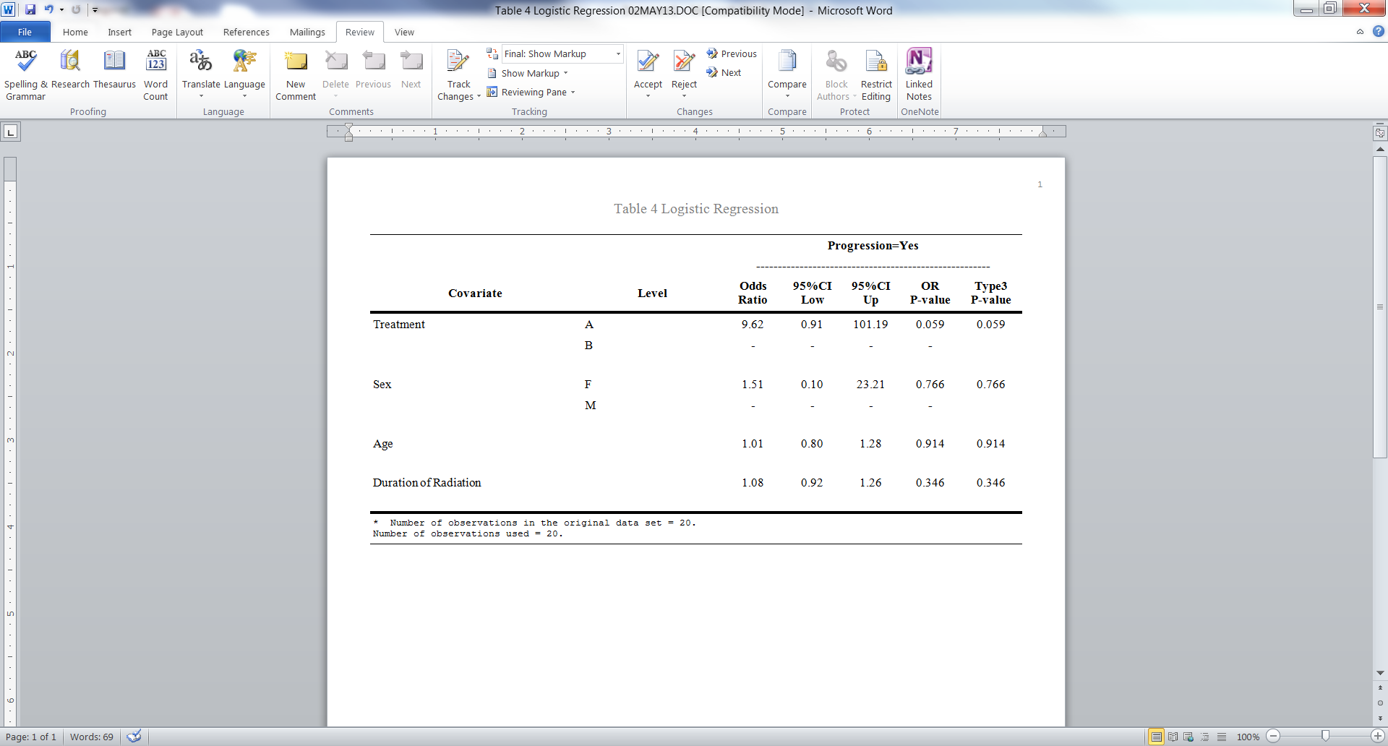

**Permission:**

Permission is hereby granted, free of charge, to any person obtaining a copy of this software and associated documentation files (the "Software"), to deal in the Software without restriction, including without limitation the rights to use, copy, modify, merge, publish, distribute, sublicense, and/or sell copies of the Software, and to permit persons to whom the Software is furnished to do so, subject to the following conditions:   
  
The above copyright notice and this permission notice shall be included in all copies or substantial portions of the Software.  
  
THE SOFTWARE IS PROVIDED "AS IS", WITHOUT WARRANTY OF ANY KIND, EXPRESS OR IMPLIED, INCLUDING BUT NOT LIMITED TO THE WARRANTIES OF MERCHANTABILITY, FITNESS FOR A PARTICULAR PURPOSE AND NONINFRINGEMENT. IN NO EVENT SHALL THE AUTHORS OR COPYRIGHT HOLDERS BE LIABLE FOR ANY CLAIM, DAMAGES OR OTHER LIABILITY, WHETHER IN AN ACTION OF CONTRACT, TORT OR OTHERWISE, ARISING FROM, OUT OF OR IN CONNECTION WITH THE SOFTWARE OR THE USE OR OTHER DEALINGS IN THE SOFTWARE.

**Log of Updates:**

|  |  |  |  |
| --- | --- | --- | --- |
| **Date** | **By** | **Description** | **Version** |
| 8/7/12 | Dana Nickleach ([dnickle@emory.edu](mailto:dnickle@emory.edu)) | Restored options at the end of the macro. | V2 |
| 8/15/12 | Dana Nickleach ([dnickle@emory.edu](mailto:dnickle@emory.edu)) | Added the debug option. | V3 |
| 9/14/12 | Dana Nickleach ([dnickle@emory.edu](mailto:dnickle@emory.edu)) | Added the footnote option, fixed column widths, and added a sort to avoid an error. | V4 |
| 10/23/12 | Dana Nickleach ([dnickle@emory.edu](mailto:dnickle@emory.edu)) | Fixed proc report ODS listing error, changed “group” to “order” to prevent note, added spanrows option, and changed length of plabel to max label length to avoid truncation. | V5 |
| 2/21/13 | Dana Nickleach ([dnickle@emory.edu](mailto:dnickle@emory.edu)) | Added outcome variable name to table. | V6 |
| 3/17/13 | Dana Nickleach ([dnickle@emory.edu](mailto:dnickle@emory.edu)) | Added TYPE3 parameter. | V7 |
| 3/18/13 | Dana Nickleach ([dnickle@emory.edu](mailto:dnickle@emory.edu)) | Fixed additional column widths so that long footnotes would not cause the table to wrap across pages and added EVENT parameter. | V8 |
| 5/3/13 | Dana Nickleach ([dnickle@emory.edu](mailto:dnickle@emory.edu)) | Fixed so that it will still run if no class variables were used and removed the DSN parameter. | V9 |
| 7/11/13 | Dana Nickleach ([dnickle@emory.edu](mailto:dnickle@emory.edu)) | Set up to handling of glogit models as well. The macro will also now require the resp data set. | V10 |
| 7/23/13 | Dana Nickleach ([dnickle@emory.edu](mailto:dnickle@emory.edu)) | Added %BQUOTE to prevent problems when outcome values contain commas or other symbols and added check to prevent specification of the EVENT parameter for clogit or glogit models. | V11 |
| 8/15/13 | Dana Nickleach ([dnickle@emory.edu](mailto:dnickle@emory.edu)) | Fixed problem caused by having a dash in the EVENT. | V12 |
| 12/18/13 | Dana Nickleach ([dnickle@emory.edu](mailto:dnickle@emory.edu)) | Fixed so that it will run correctly when no class variables are used in a clogit or glogit model; fixed bug in reporting reference category in glogit model and removed extra space in table header; and fixed problem with multiple lengths of the response variable in merge for glogit case. | V13 |
| 3/19/14 | Dana Nickleach ([dnickle@emory.edu](mailto:dnickle@emory.edu)) | Collapsed OR and CI into one column. | V14 |
| 2/2/2015 | Yuan Liu | Add EFFECT, SLICEBY, SHORTREPORT, and ORIENTATION. Now the macro allows interaction in the model | V15 |
| Mar, 2016 | Yaqi Jia, Yuan Liu | Add CLNUM to allow user seeing the frequency of categorical variable in the final model | V16 |